Theme: Student Finance Tracker

Data model

{
"id": "txn_1",
"description": "Lunch at cafeteria",
"amount": 3000,
"category": "Food",
"date": "2026-10-13",
"createdAt": "2026-10-13T12:30:00Z",
"updatedAt": "2026-10-13T12:30:00Z"
}

{
"baseCurrency": "RWF",
"otherCurrencies": [
{ "code": "USD", "rate": 1430 },
{ "code": "EUR", "rate": 1700 }
],
"spendingLimit": 5000,
"categories": ["Food", "Books", "Transport", "Entertainment", "Fees", "Other"]
}

Accessibility list

Structure
Page uses header, nav, main, footer
One main title per page, then smaller headings under it
Keyboard
“Skip to content” link is the first thing you reach with Tab
Everything can be done with Tab, Enter and Space, no mouse needed
A visible outline shows which item is selected

Forms
Every box has a label connected to it
Error messages show right under the box
Errors and success messages are announced to screen readers (live regions)
Spending limit message
Under the limit: a polite announcement
Over the limit: an urgent announcement
Text and background have enough contrast (4.5 to 1)
Layout works on phone, tablet and computer (360px, 768px, 1024px)
Looks and search
Matches are marked so they’re clear, without breaking the text for screen readers

This is the spending record and how it should look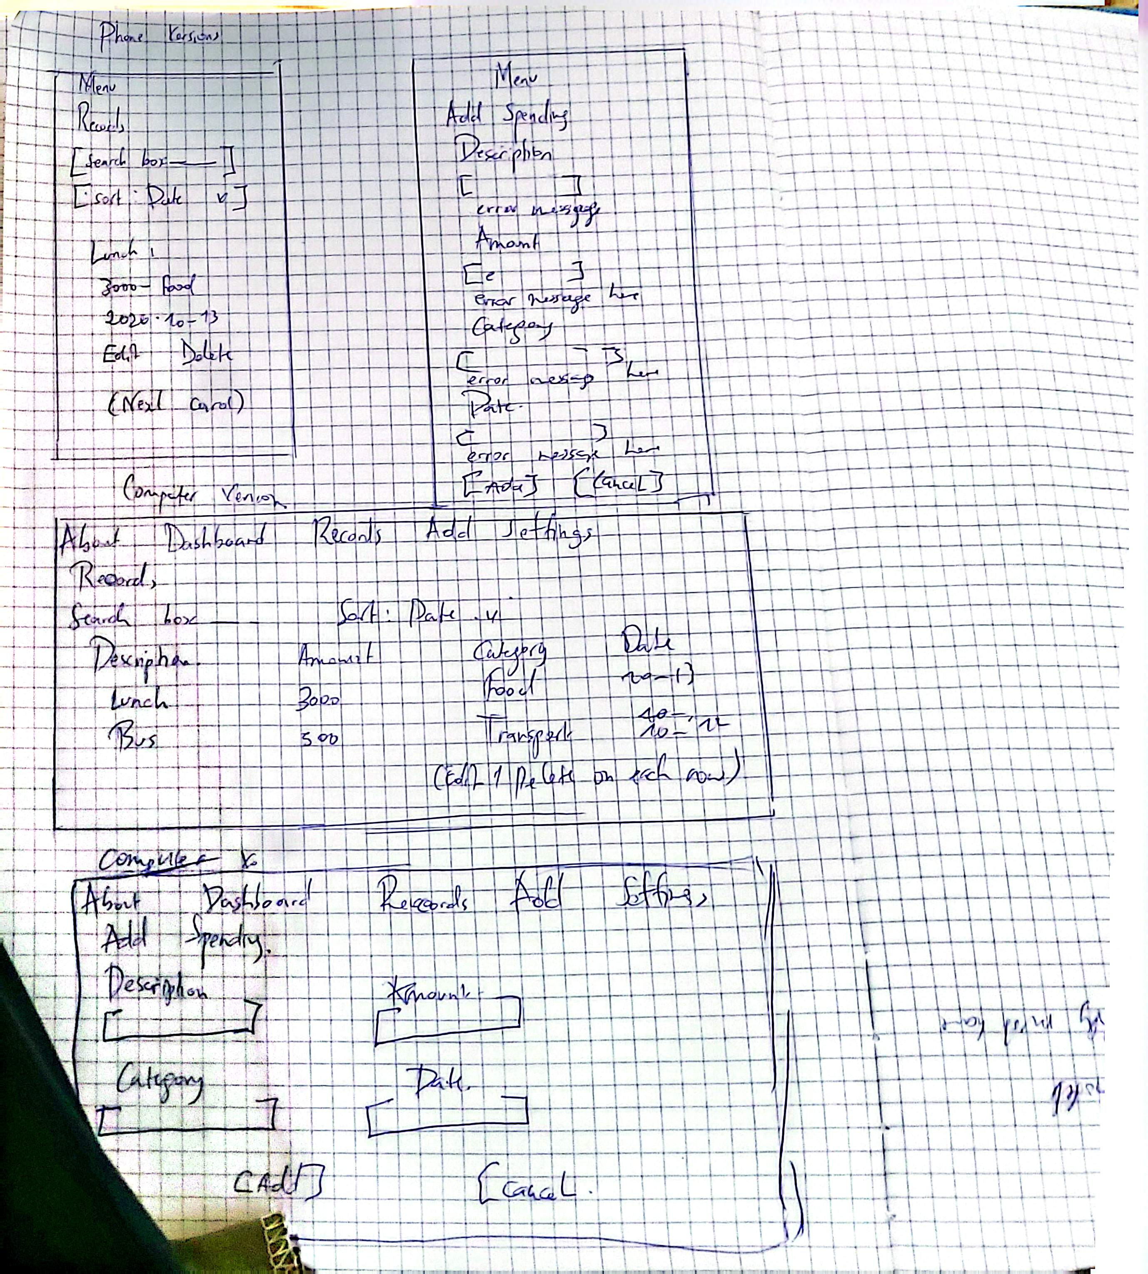

This is the settings in computer version
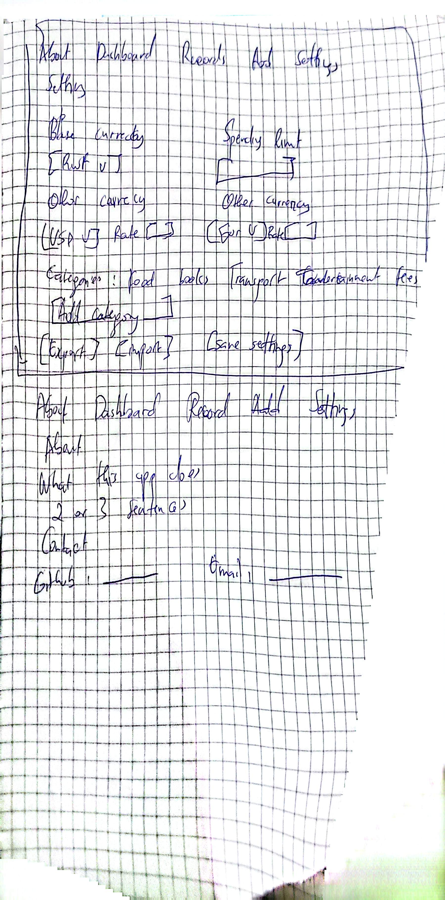
Both the phone version and computer for the records

